Tuesday 4th May 2021

Dear Parents and Carers,

It is with much regret that I write to inform you that Mrs. Theresa Kyeyune, our School Counsellor, will be leaving John Perryn Primary at the end of this academic year. Mrs. Kyeyune has been a valued member of the school team since 2017 and will be greatly missed by staff, children and families alike.

I understand that this will come as a shock to many of you, and I wanted to write to reassure you that we will be continuing to provide therapeutic work for our children, families and staff at John Perryn next year and beyond. From September 2021, we will be partnering with Ealing Schools Counselling Service, who will provide a number of services as detailed below.

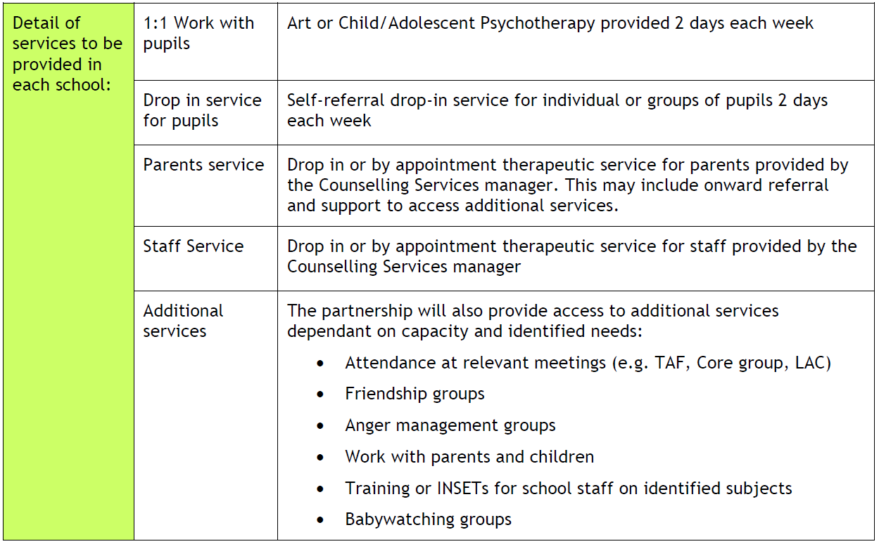
I hope that the knowledge that we will be continuing therapeutic services will go some way towards reassuring you that we will continue to strive to support all of our families to the very best of our ability.

Below is a message from Mrs. Kyeyune to our families.

Yours sincerely,

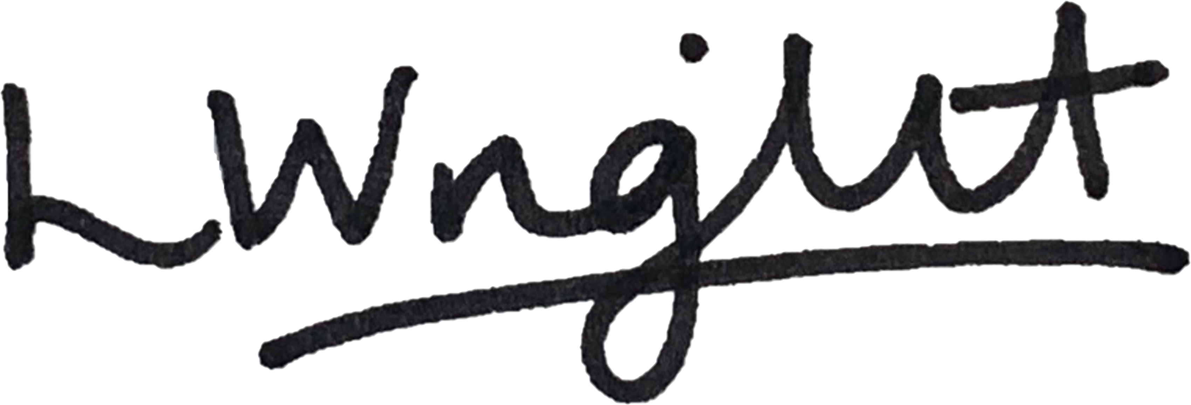

Ms. Leah Wright
Head Teacher

Dear Parents/Carers and families of John Perryn,
It is with a great sadness that I find myself writing this letter to you.
In January of 2020, I launched my own company to enable me to work in private practice as a Therapist. It was my hope that, at the end of my fixed term contract with the school, I would be able to continue my work at John Perryn. However, due to government legislation this will not be possible. Therefore, I will be ending my role as the John Perryn School Counsellor at the end of this academic year in July 2021.
I would like to take this opportunity to thank you for your ongoing support and the very warm welcome you extended to me when I joined the school in 2017.
John Perryn will always hold a very special place in my heart, and of course I will come back to visit.
I wish you all the very best for the future.
Kindest regards,
Theresa Kyeyune

